

Imam Mohammad Ibn Saud Islamic University
College of Computer and Information Sciences
Computer Science Department

Course Title: | Software Engineering 1
Course Code: | CS1350
Instructor: | Dr. Gufran Ahmad Ansari
Semester: | 2nd Semester, 2026

Group | Section | ID | Name
3 | 173 | 446016877 | Wadeea Hazim Musleh
3 | 173 | 446016880 | Ayham Nabel Al Mousa
3 | 173 | 446016867 | Salem Lathkani
3 | 173 | 446016885 | Hassan Abdullah
Centralized Railway Reservation and Management System

Contents
PHASE 1 3
INTRODUCTION 4
PROJECT SCOPE 5
PROJECT TARGET AUDIENCE 5
CHARACTERISTICS AND CAPABILITIES 6
PRODUCT BACKLOG 6
Backlog: 6
Sprint 1: 7
Sprint 2: 7
Sprint 3: 8
MEETING PARTICIPANTS 8
PHASE 2 9
INTRODUCTION 10
LAYERED ARCHITECTURE DIAGRAM 10
Common Layers in Layered Architecture 10
The reason for choosing the Layered Architecture Diagram 12
UNIFIED MODELING LANGUAGE (UML) 12
USE CASE DIAGRAM 13
Use case scenario 14
SEQUENCE DIAGRAM 14
SEQUENCE DIAGRAM FOR THE USER 15
SEQUENCE DIAGRAM FOR THE ADMIN 16
CLASS DIAGRAM 17
ACTIVITY DIAGRAM 18
Activity diagram for the user 18
Activity diagram for the admin and the system 19

PHASE 1

INTRODUCTION
Modern transportation relies heavily on efficient, reliable, and well-organized railway networks. To address the growing need for streamlined operations and to reduce manual errors in booking and ticket processing, we introduce the Centralized Railway Reservation and Management System.
This project aims to centralize train scheduling and reservation data into a single, integrated cloud-based web application. Designed to enhance operational organization and improve data accuracy , the system provides structured data management capabilities through a secure, user-friendly interface. It empowers railway administrators, booking staff, and system managers to seamlessly manage train schedules, monitor seat availability, and oversee the entire booking process.
The platform offers a comprehensive suite of features, including:
- Dynamic Ticketing & Scheduling: A robust reservation module that processes tickets and updates seat capacity automatically alongside detailed route and schedule management.
- Passenger Management: Efficient tools for registering, storing, and updating passenger profiles and contact information.
- Data-Driven Insights: An administrative dashboard equipped with reporting and analytics tools to generate daily, weekly, and monthly reports on bookings and revenue, directly supporting strategic decision-making.
- Robust Security: Strict adherence to data security and privacy through secure authentication, role-based access control, and reliable backup and recovery processes.
Ultimately, this system bridges the gap between complex railway operations and customer convenience, providing a modern solution that benefits both the service providers and the passengers.

PROJECT SCOPE
This section defines what the system will do and what it will include:
- The system will manage train schedules, and define departure and arrival times
- The system will specify seat capacity and its price, and support ticket cancellation.
- The system will manage passenger information such as their name, numbers, contact information, and their train information.
- The system provides change process for passenger information.
- The system provides storing process for passenger information in the database.
- The system provides administrative dashboard.
- The system provides reporting and analysis it can be daily, weekly, and monthly reports.
- The system ensures data security and privacy.

PROJECT OBJECTIVE
- To centralize train scheduling and reservation data in one integrated system.
- To provide structured data management capabilities through a secure, user-friendly interface.
- To enable railway administrators to manage train schedules, monitor seat availability, booking process.
- To generate reports and support decision-making.
- To enhance operational organization and improve data accuracy.
- To facilitate reservation and register update and store passenger information.
- To reduce manual errors in booking and ticket processing.
- To implement secure authentication and role-based access control.

PROJECT TARGET AUDIENCE
- Railway Administrators.
- Booking staff.
- System Managers/Administrators.
- Customers

CHARACTERISTICS AND CAPABILITIES
- Train and Schedule Management: Maintain train scheduling and Define routes, departure, and arrival times and the seat capacity.
- Passenger Information Management: Providing the ability of register and storing and updating information for passengers’ profiles.
- Reservation and Ticketing Module: Process the operations on tickets and update seat capacity automatically.
- Administrative Dashboard: Display summary statistics (total trains, bookings, revenue).
- Reporting and Analytics: Generate booking and revenue and train utilization reports.
- Platform: Providing a cloud-based web application to the system.
- Data Security and Privacy: Limited access control by authentication and maintain data integrity and provide backup and recovery.

PRODUCT BACKLOG

Backlog:
This image shows a Product Backlog for a train reservation and management system. It lists various user stories divided into three sprints based on their priority level.
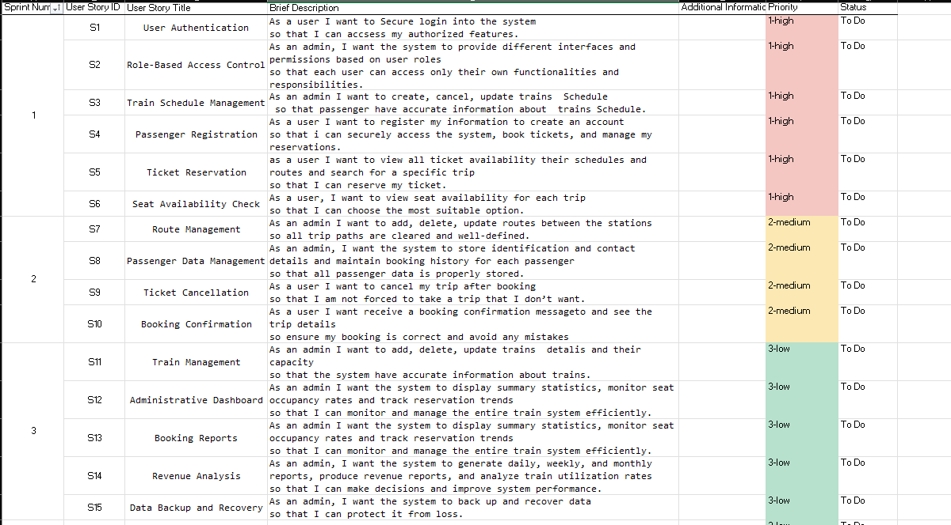
Figure 1.0: The figure shows the user stories and the description with the priority.

Sprint 1:
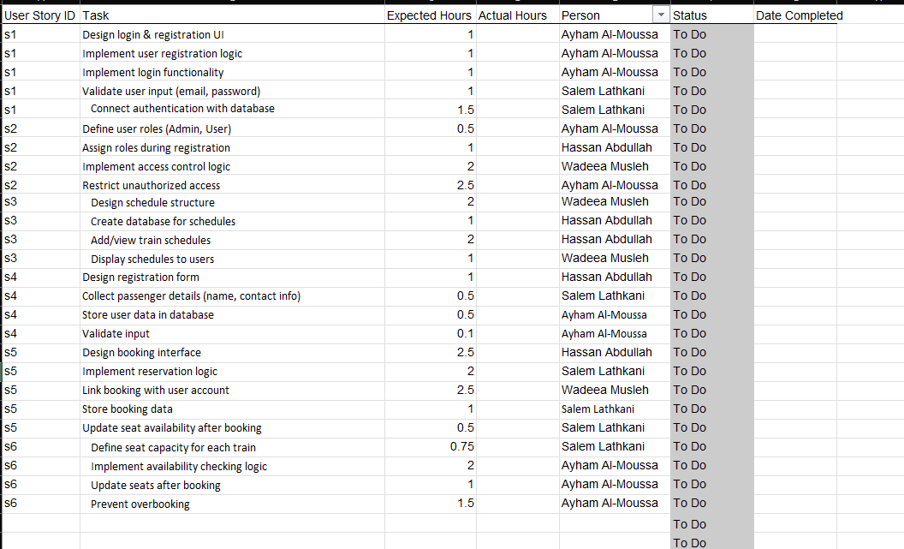
Figure 1.1: The first sprint’s tasks with expected hours and the person who is responsible about it.

Sprint 2:
Figure 1.2: The second sprint’s tasks with expected hours and the person who is responsible about it.
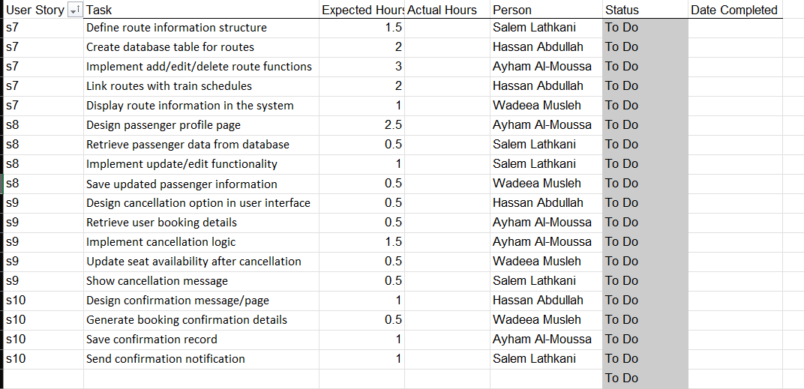

Sprint 3:
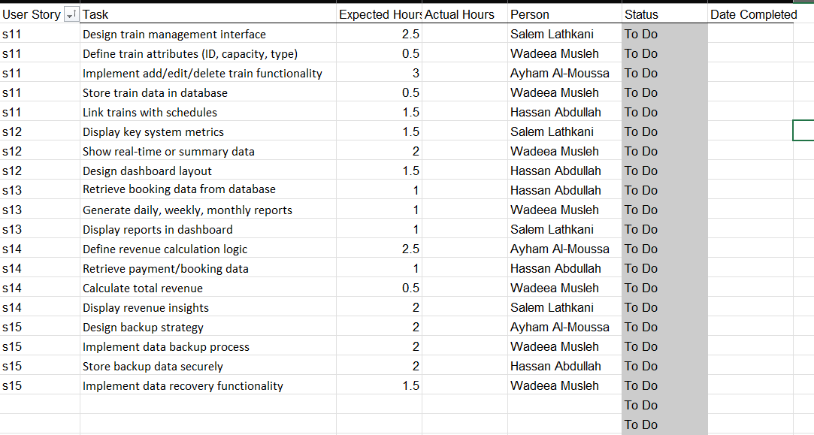
Figure 1.3: The third sprint’s tasks with expected hours and the person who is responsible about it.

MEETING PARTICIPANTS
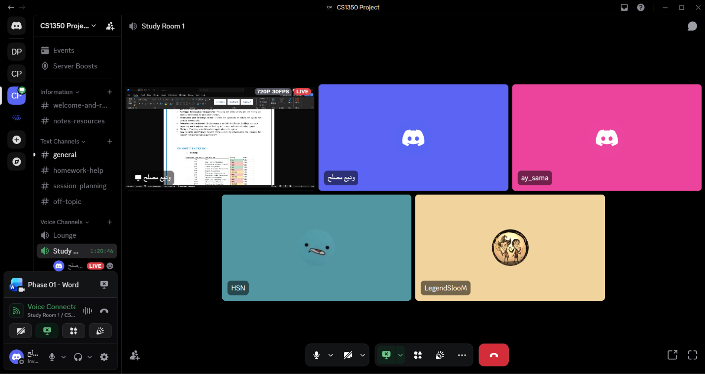
Figure 1.4: The participants in the meeting of the project.

PHASE 2

INTRODUCTION
This report presents Phase of the Centralized Railway Reservation and Management System development. Following the successful gathering of requirements and the establishment of the Product Backlog in the initial phase, the focus now shifts toward the architectural design and technical modeling of the system. This phase serves as a crucial bridge between theoretical requirements and practical software development.
The primary objective of this phase is to translate the gathered requirements into clear, executable structural and behavioral designs. This document covers the following key architectural and implementation aspects:

System Modeling: Providing comprehensive interactional, behavioral, and structural models using Use Case, Sequence, Class, and Activity diagrams to ensure accurate coverage of all system requirements.

Architectural Design: Selecting and defining the appropriate architectural pattern for the system. This includes outlining system components, their interactions, and providing an engineering justification based on the project's needs for functionality.

Initial Implementation: Showcasing an early prototype of the system, supported by sample source code and screenshots demonstrating the successfully executed features.

Ultimately, this report establishes the engineering foundation necessary to proceed with full-scale development, ensuring the delivery of a robust, well-structured, and reliable railway management system.

LAYERED ARCHITECTURE DIAGRAM
Layered architecture divides a software application into vertical layers, with each layer focusing on a specific responsibility. The layers work together to process data, handle business logic, and interact with users, ensuring that no single layer bears the weight of all responsibilities.[2]

Common Layers in Layered Architecture
- Presentation Layer:
Handles the user interface and user interactions.
- Business Layer:
Processes the application's business rules and workflows.

- Persistence Layer:
Manages data storage and retrieval.
- Database Layer:
The actual data storage system where information is saved.

Figure 2.0: Layered Architecture Diagram for the Train Reservation System — illustrating the separation of concerns across five tiers: Presentation, Application, Business Logic, Data Access, and Database.
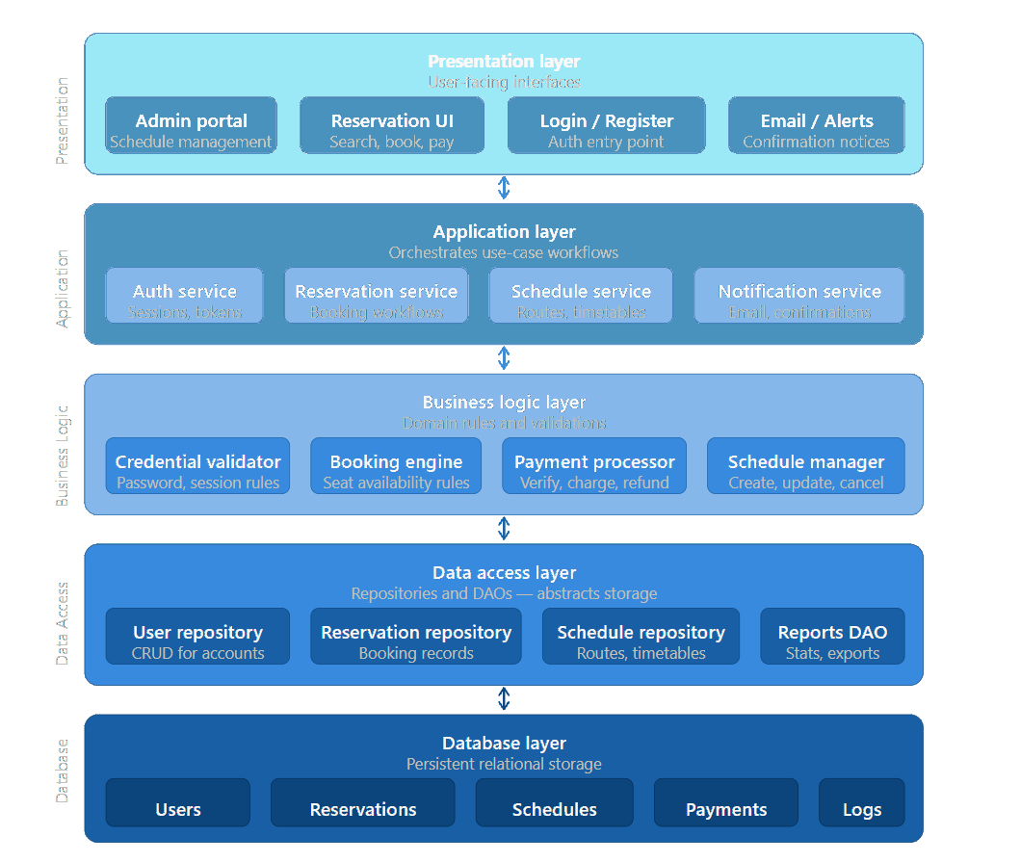

The reason for choosing the Layered Architecture Diagram
1. Separation of Concerns Each layer is responsible for one specific function only — the UI knows nothing about the database, and the database knows nothing about the UI. This keeps the system clean and easy to understand.
2. Maintainability If you need to modify the payment logic, you only change the Business Logic Layer without touching the rest. This significantly reduces the risk of introducing bugs during updates.
3. Reusability Services in the Application Layer such as the Notification Service or Auth Service can be used from multiple entry points — both the Admin Portal and the User Reservation UI — without duplicating code.
4. Testability Each layer can be tested independently. You can test the Business Logic without running the database, and test the UI without needing the full backend up and running.
5. Security Users never access the database directly. Every request passes through the Presentation, then Application, then Business Logic layers before reaching the data — adding multiple layers of protection.
6. Scalability Each layer can be developed and scaled independently. For example, you can optimize the Data Access Layer or swap out the database engine without affecting the rest of the system.
7. Team Familiarity Layered Architecture is one of the most well-known patterns among developers, making it easy for any new team member to quickly understand the project structure and start contributing.

UNIFIED MODELING LANGUAGE (UML)
Unified Modeling Language (UML) is a general-purpose modeling language. The main aim of UML is to define a standard way to visualize the way a system has been designed. It is quite similar to blueprints used in other fields of engineering. UML is not a programming language, it is rather a visual language. [1]
- UML is a standardized modeling language (approved by ISO) that provides a common way for teams to visualize and communicate system design.
- We use UML diagrams to show the behavior and structure of a system.
- UML helps software engineers, businessmen, and system architects with modeling, design, and analysis.
- The International Organization for Standardization (ISO) published UML as an approved standard in 2005. UML has been revised over the years and is reviewed periodically.

USE CASE DIAGRAM
A UML use case diagram is the primary form of system/software requirements for a new software program underdeveloped. Use cases specify the expected behavior (what), and not the exact method of making it happen (how). Use cases once specified can be denoted both textual and visual representation (i.e. use case diagram). A key concept of use case modeling is that it helps us design a system from the end user's perspective. It is an effective technique for communicating system behavior in the user's terms by specifying all externally visible system behavior.[3]
A use case diagram is usually simple. It does not show the details of the use cases:
Figure 2.1: This diagram represents the Centralized Railway Reservation System and shows how users interact with the system.
There are two actors:
Passenger User: can register, login, check seat availability, book tickets, and cancel tickets.
Administrator: manages schedules, routes, train details, reports, and data backup.
Some operations such as Book Ticket and Cancel Ticket require Login (<<include>> relationship).
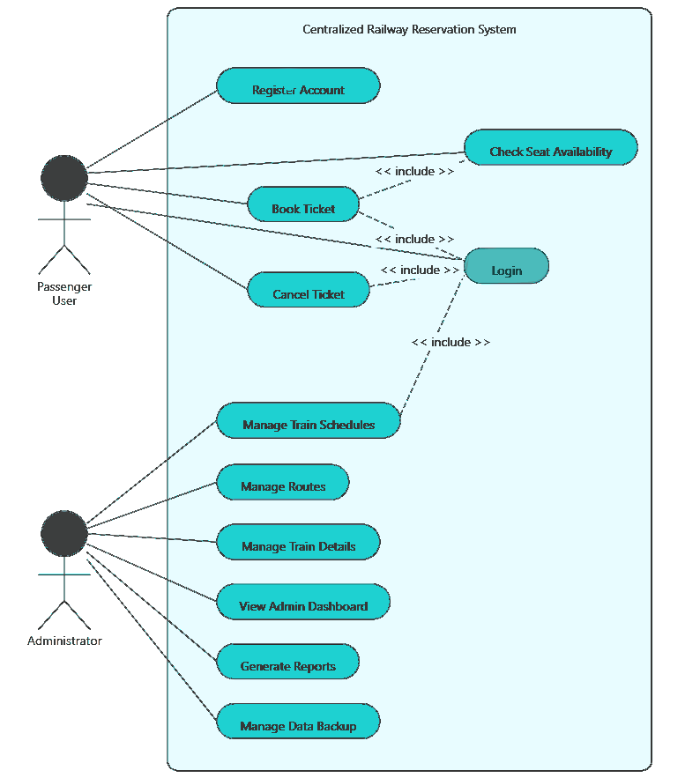

er

Use case scenario
Use Case: Book a Train Ticket
Primary Actor: Passenger

Preconditions:
- Passenger must be registered and logged in
- Train schedules must be available

Main Success Scenario:
1. User navigates to "Book Ticket"
2. User enters departure, destination, and travel date
3. System displays available trips
4. User selects a trip
5. System displays available seats
6. User selects a seat
7. User confirms booking
8. System associates booking with user account
9. System updates seat availability
10. System saves booking
11. System displays confirmation message

Alternative Flows:
- At Step 3: If no trips available → system shows "No trips available"
- At Step 5: If train is full → system shows "Sold Out" and prevents booking

Postconditions:
- Booking is saved successfully
- Seat availability is updated

SEQUENCE DIAGRAM
A UML sequence diagram is a graphical representation that depicts the interaction of objects in a system over time. These diagrams capture the sequence of messages exchanged between objects and the order in which these interactions occur, presenting them as vertical lifelines and horizontal arrows. Essentially, sequence diagrams provide a chronological visualization of object interactions, offering insights into the dynamic behavior and flow of a system.[4]

SEQUENCE DIAGRAM FOR THE USER
Figure 2.2: this diagram illustrates how the user logs in, searches and books trips, processes payment, and can cancel bookings with validation steps.

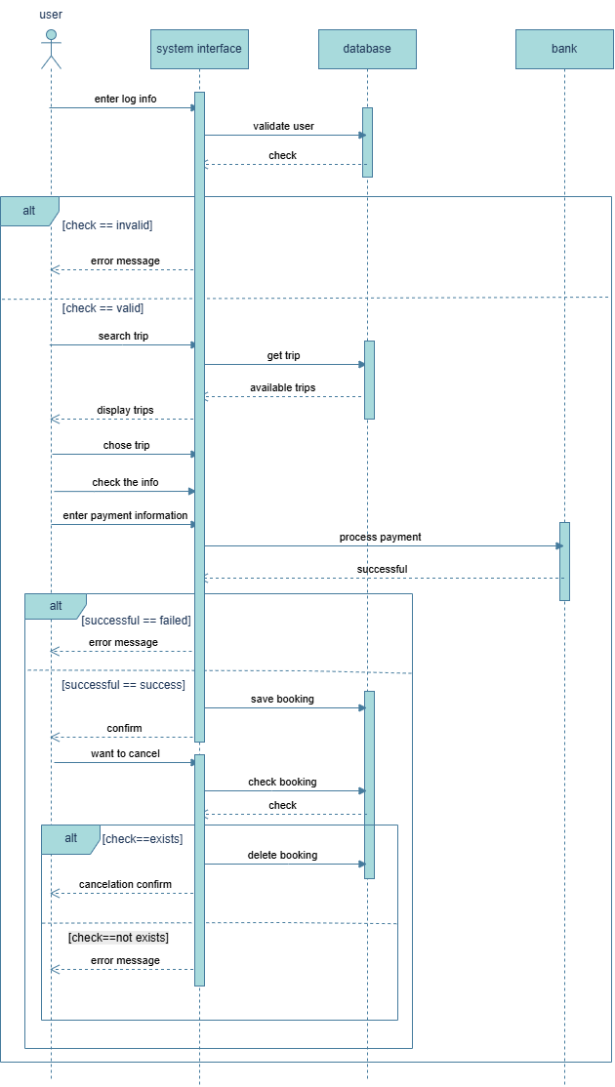

SEQUENCE DIAGRAM FOR THE ADMIN
Figure 2.3: This diagram shows how the admin logs in, manages trips (create/update/delete), generates reports and statistics, and performs backup operations with system validation

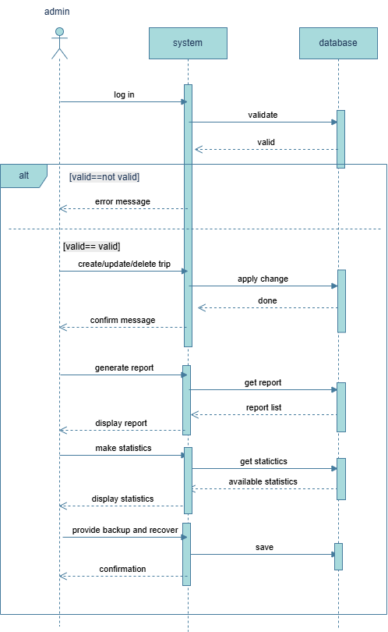

CLASS DIAGRAM
The class diagram is the main building block of object-oriented modeling. It is used for general conceptual modeling of the structure of the application, and for detailed modeling to translate the models into programming code. Class diagrams can also be used for data modeling. The classes in a class diagram represent both the main elements, interactions in the application, and the classes to be programmed.
Figure 2.4: This class diagram represents the structure of the Train Reservation System, showing the main entities and their relationships. The system is organized into four main parts: Users, Resources, Operations, and Transactions. Inheritance is used to differentiate user roles (Admin and Passenger), while associations and composition illustrate how bookings, trains, seats, and payments interact. This design supports modularity, maintainability, and scalability of system.[5]
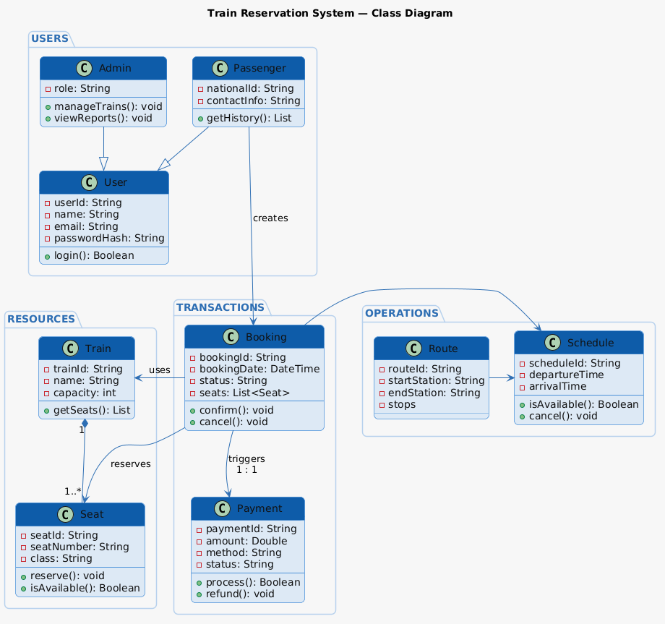

ACTIVITY DIAGRAM
Activity diagrams can be used to describe time sequences. This makes it possible to describe processes, workflows and algorithms at different levels of abstraction. Activity diagrams are often used to describe use cases in more detail.
It is possible to visualize even very complex processes with many exceptions, variants, jumps and repetitions in a clear and comprehensible way.[6]

Activity diagram for the user
Figure 2.5: illustrates the workflow of System, starting from login or account creation to searching for trips, selecting a trip, and completing the payment process. It also shows decision points such as incorrect input, trip availability, and payment success. The diagram ensures a clear understanding of the user interactions and system responses throughout the booking process.
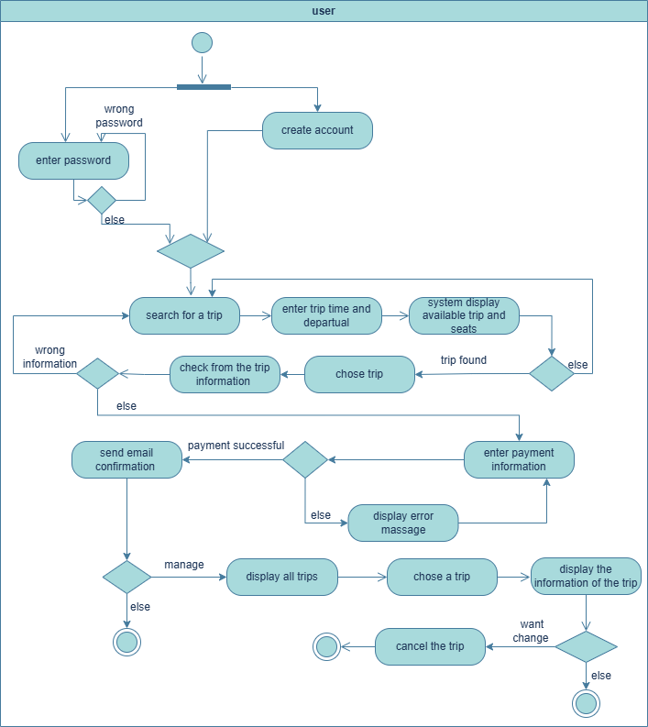

Activity diagram for the admin and the system
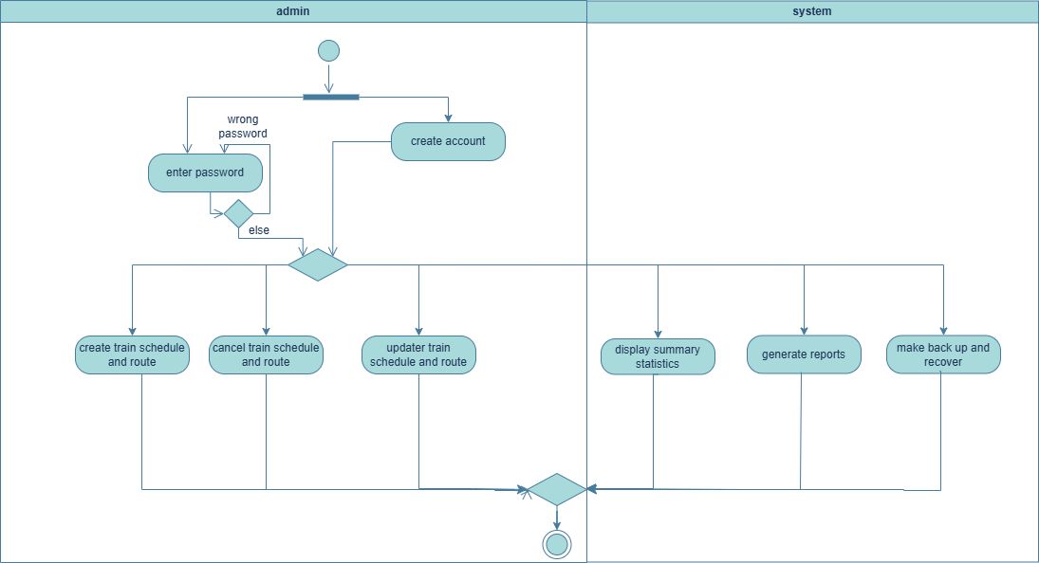
Figure 2.6: This activity diagram represents the workflow of the admin in the Train Reservation System, starting from login or account creation to managing system operations. The admin can create, update, or cancel train schedules and routes, as well as view system statistics, generate reports, and perform backup and recovery. The diagram highlights decision points and system interactions to ensure efficient system management.

IMPLEMENTATION
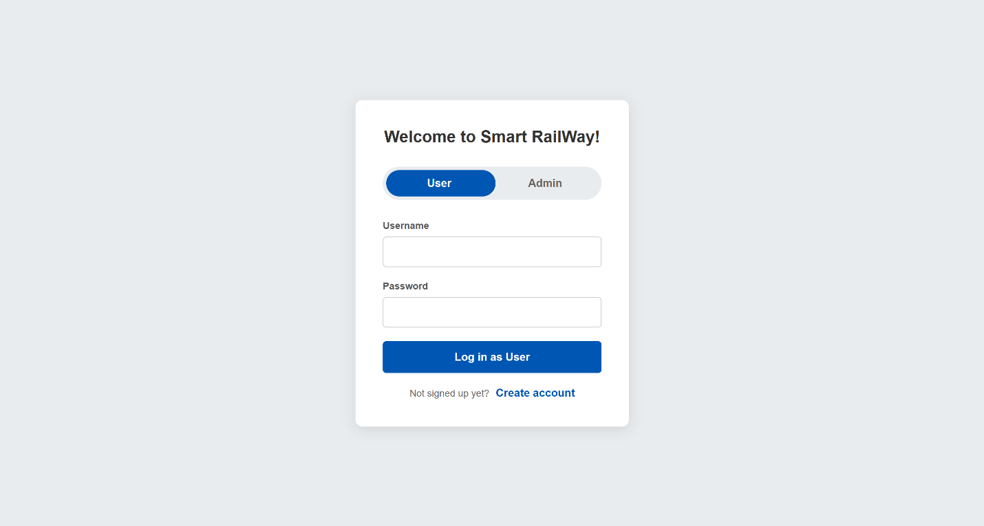
Figure 2.7: user log-in screen.
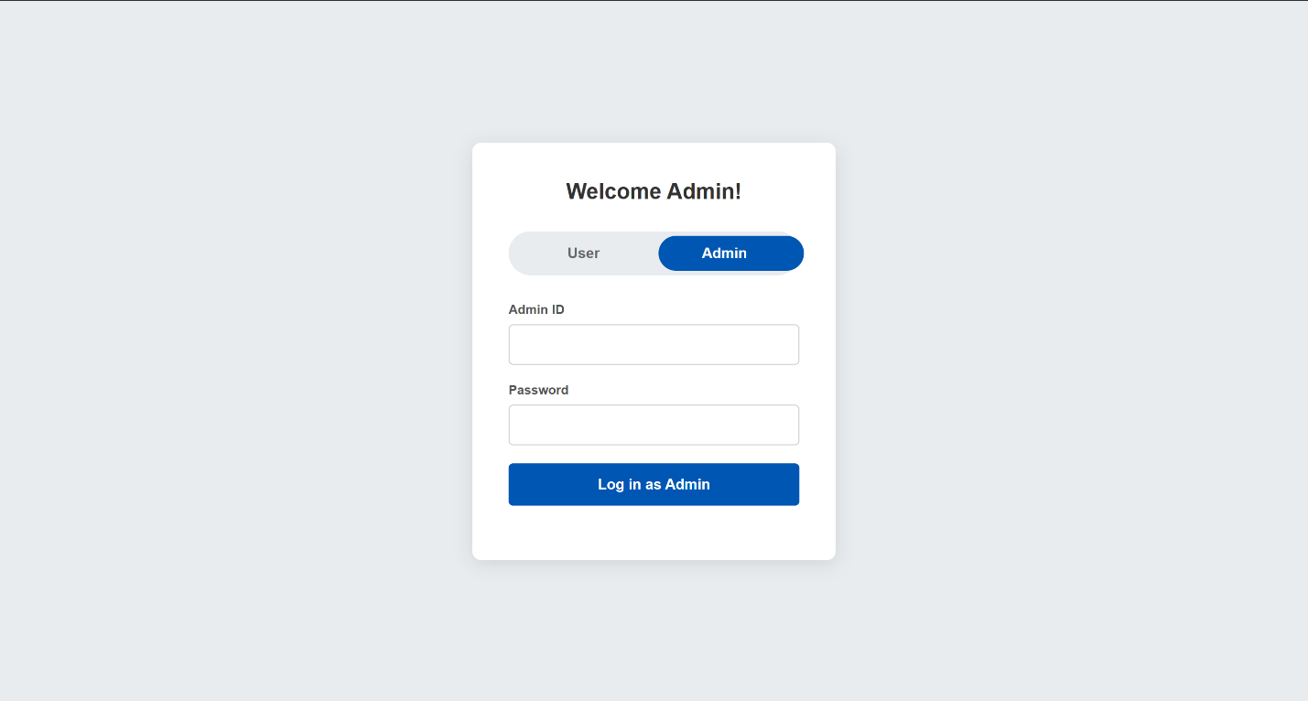
Figure 2.8: admin log-in screen.

Figure 2.9: the user table in the database that show id, name, phone, email, Bdate, and booking.
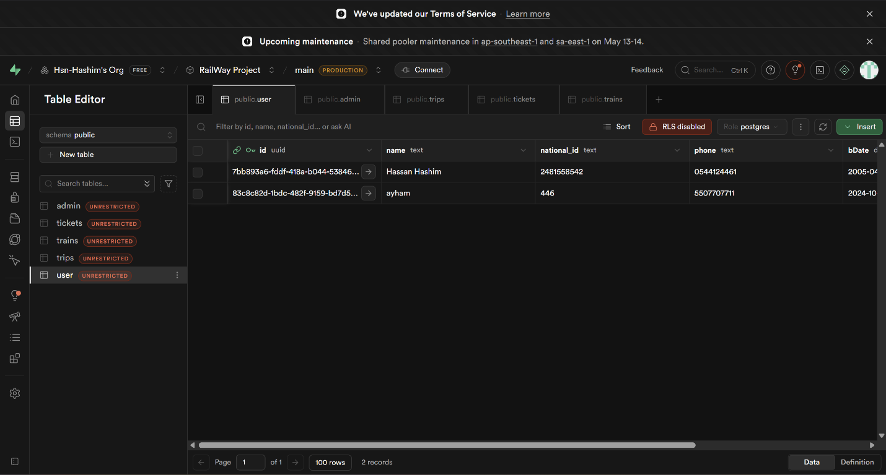
References
-Github link: https://github.com/Hsn-Hashim/railWay-project
[1] -Geeks for Geeks
https://www.geeksforgeeks.org/system-design/unified-modeling-language-uml-introduction/
[2] -Dev community
https://dev.to/yasmine_ddec94f4d4/understanding-the-layered-architecture-pattern-a-comprehensive-guide-1e2j
[3] -visual paradigm
https://www.visual-paradigm.com/guide/uml-unified-modeling-language/what-is-use-case-diagram/
[4] -Miro
https://miro.com/diagramming/what-is-a-uml-sequence-diagram/#defining-what-a-uml-sequence-diagram-is
[5] -mermaid
https://mermaid.ai/open-source/syntax/classDiagram.html
[6] - sparxsystems.eu
https://www.sparxsystems.eu/languages/uml/diagrams/activitydiagram/
[7] -for drawing we use:
1-Draw io
https://www.drawio.com/
2-plantuml
https://plantuml.com/

